Experiment No:01

Experiment Name: Setup Linux Mint in the PC.

Aim and Objectives: Main goal of this lab is to provide a way how to install Linux Mint 18.2 in pc. Linux is open source OS. Anybody can have developed Linux for his own benefits.

* To make secured the system.
* To make stable.
* To use command line interface.
* To manage extremely huge amounts of data efficiently.

**Experimental Setup:**

We use Oracle VM VirtualBox manager to setup Linux mint over windows operating system.

Procedure for setup Linux mint step by step is given below.

Step 1: click the start button of VM VirtualBox manager. Then it will be moved on the next step.

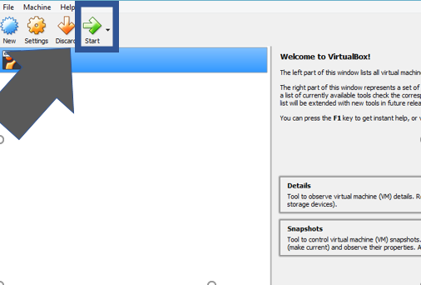

Step 2: Click on linux-mint installation button. Then it will be moved on the next step.

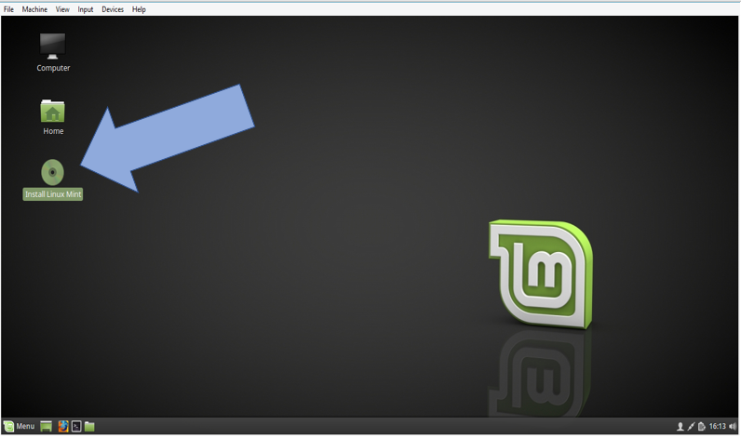

Step 3: select language.the arrow gives the language selection.then Click on continue button

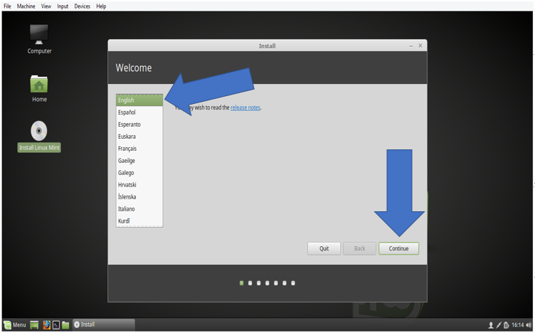

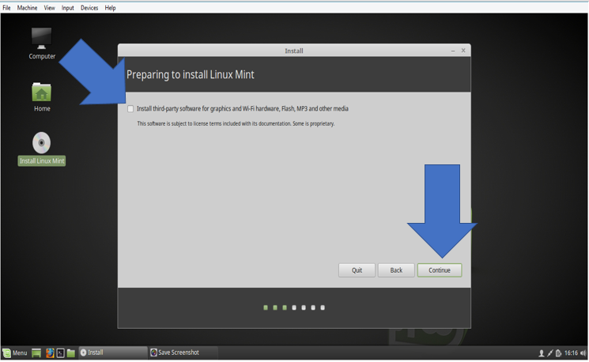

Step 4:Select the type of install which type you want to install and then click on install now button.after click on continue button.

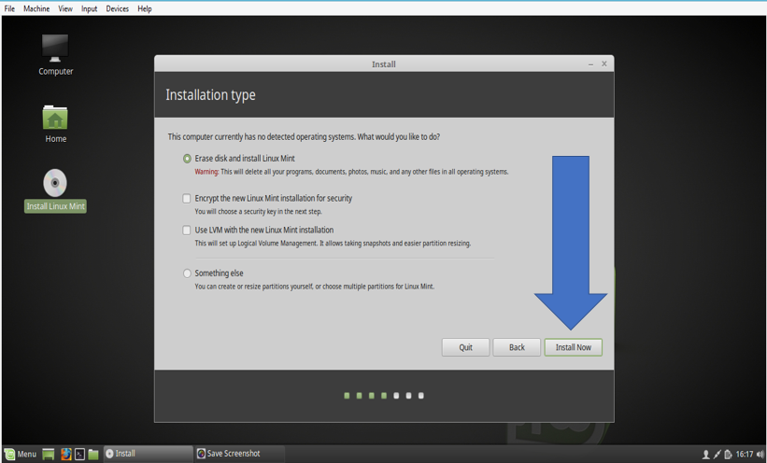

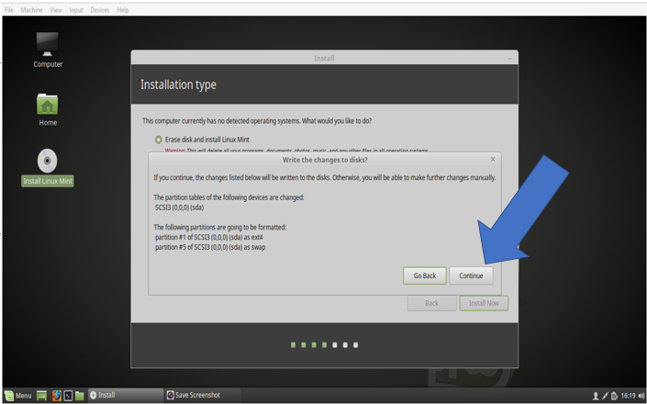

Step 5:select the city where are you live and click continue button.

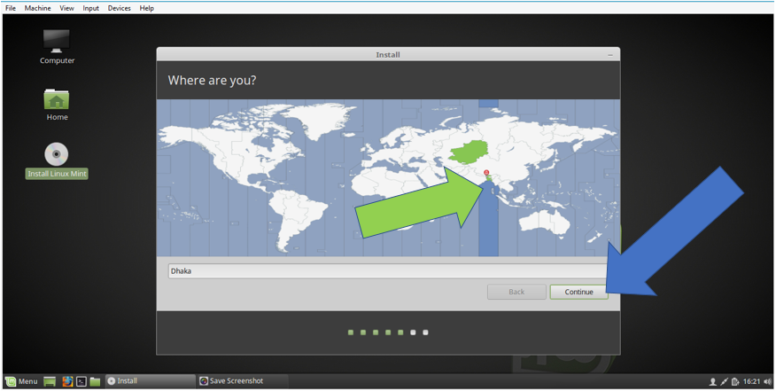

Step 6:selct language and click on continue button.

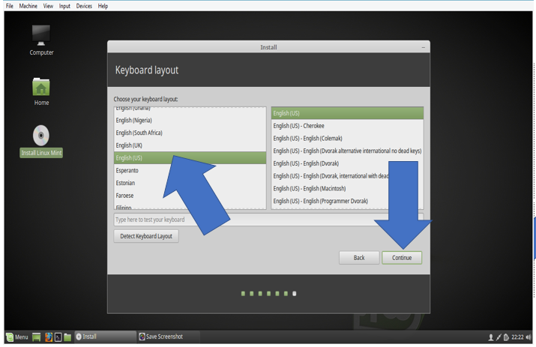

Step 7:linux installing are in progress.

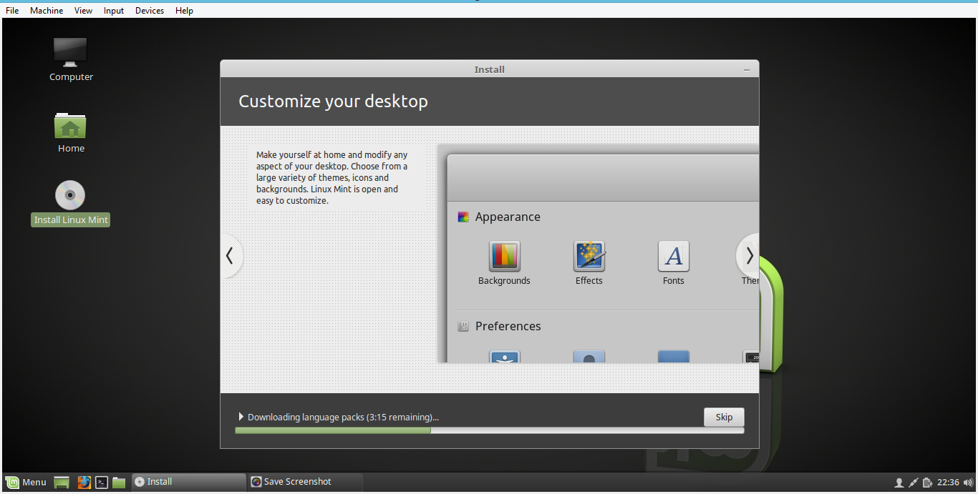

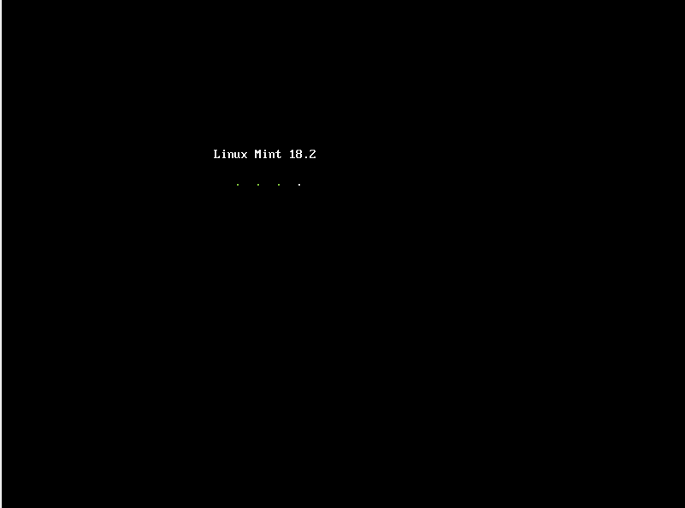

Step 8:login username and password scren.

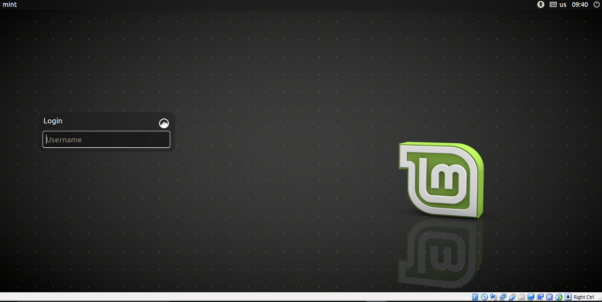

Step 9:finally linuxmint is installed and below the welcome screen.

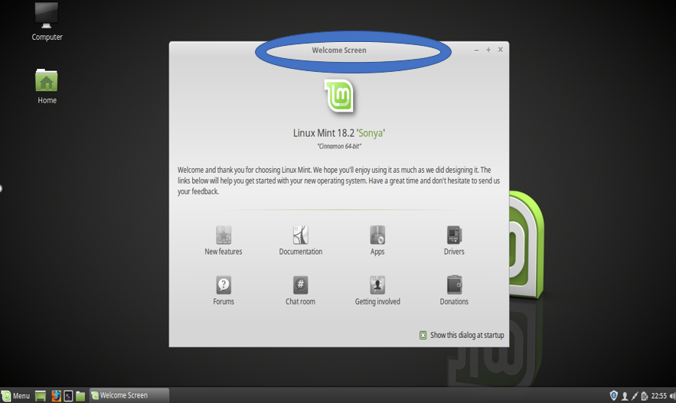

Conclusion:

Linux is a highly secured operating system. Unlike windows OS, it doesn’t allow any kind of virus. For this, no risky think happened in Linux about virus.it is stable then other operating system. after all we use it as free. So, it is significant to mark that the benefit of Linux operating system is remarkable.